Resume Building:
Steps to follow
Different category folks

Points to remember:
Use the resume samples (3 samples for format, master document for points).
Complete the resume building today itself, immediately.
Do not take points from samples, not even one point.
Take points from master document.
At the top of your resume, please put your current status. Ex: IT java, NON IT, GAP
Take points from master document which u feel comfortable.,
Definitely, put AWS Pyspark points.
Do not mention any verions for the tools,
Put the experience in the descending order( recent should be at the top)
Make your resumes as unique as possible, put some logos, put some unique points use chatgpt
Complete gold video immediately.
Complete python tutorials.
Complete the scenarios which are posted in groups.

Different category folks:
IT:
Use same organization, same project and client name, role should be BIG DATA DEVELOPER/BOG DATA ENGINEER/HADOOP DEVELOPER/ LCOUD DATA ENGINEER/ DATA ENGINEER.
No need to put you designation.
4 -7 years put 3 or 4 years i BIG DATA Engineer.

Non it:
Use the same orgs name,
Role as big data engg/ cloud data engg
No need to put your designation.
Don’t put your non IT Roles.
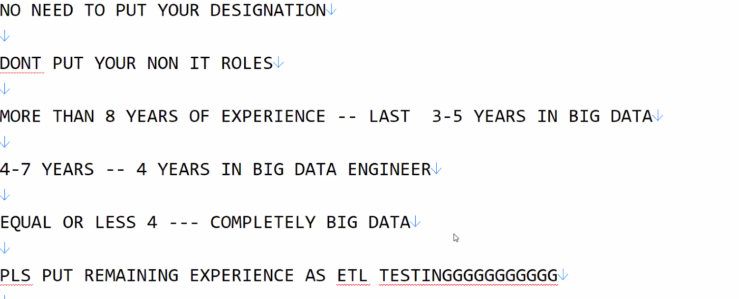
IT / NON IT:
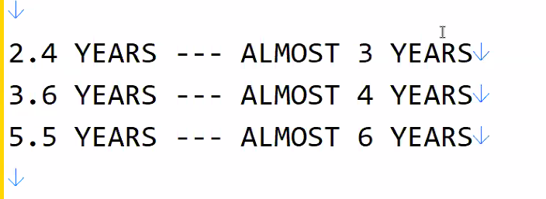

Points to remember

Use the resume samples (3 samples for format,Master document for points)
Complete the resume building today itself - 30 Minutes
DO NOT DO NOT DO NOT DO NOT DO NOT DO NOT DO NOT TAKE POINTS FROM SAMPLES
NOT EVEN ONE POINT YOU SHOULD TAKE FROM SAMPLES
TAKE POINTS ONLY FROM MASTER DOCUMENT
AT THE TOP OF RESUME --- PLEASE PUT YOUR CURRENT STATUS
EG -- IT JAVA / NON IT / GAP --- 3 YEARS
TAKE POINTS FROM MASTER DOCUMENT WHICH YOU FEEL COMFORTABLE
DEFINITELY DEFINITELY -- PUT AWS PYSPARK POINTS
DO NOT MENTION ANY VERSION FOR THE TOOLS
PUT THE EXPERIENCE IN THE DESCENDING ORDER (RECENT SHOULD BE AT THE TOP)
MAKE YOUR RESUMES AS UNIQUE AS POSSIBLE (PUT SOME LOGOs,put some unique- use chatgpt)
COMPLETEEEEE GOLD VIDEO IMMEDIATELYYYYYYYYYYYYYYYYYY
COMPLETEEEEE PYTHON TUTORIALS (39 TUTORIALS)
COMPLETEEEEE THE SCENARIOS which am going post
WHILE PREPARING THE RESUME - DOUBT,STRUCK,CONFUSION -- BUT PUT WHAT EVER YOU FEEL - WILL CORRECT DURING REVIEW
DIFFERENT CATEGORY FOLKS (IT/NON IT/GAP)
==================
IT ----
==================
Use Same organization -- SAME PROJECT /CLIENT NAME
ROLE ---- BIG DATA DEVELOPER / BIG DATA ENGINEER /SPARK DEVELOPER/HADOOP DEVELOPER / DATA ENGINEER / CLOUD DATA ENGINEER
NO NEED TO PUT YOUR DESIGNATION
MORE THAN 8 YEARS OF EXPERIENCE -- LAST 3-5 YEARS IN BIG DATA
4-7 YEARS -- 4 YEARS IN BIG DATA ENGINEER
EQUAL OR LESS 4 --- COMPLETELY BIG DATA
REMAINING EXPERIENCE YOU PUT YOUR SKILL SET ITSELF
==================
NON IT
==================
USE THE SAME ORGANIZATION NAME
ROLE --- BIG DATA DEVELOPER / BIG DATA ENGINEER /SPARK DEVELOPER/HADOOP DEVELOPER / DATA ENGINEER / CLOUD DATA ENGINEER
NO NEED TO PUT YOUR DESIGNATION
DONT PUT YOUR NON IT ROLES
MORE THAN 8 YEARS OF EXPERIENCE -- LAST 3-5 YEARS IN BIG DATA
4-7 YEARS -- 4 YEARS IN BIG DATA ENGINEER
EQUAL OR LESS 4 --- COMPLETELY BIG DATA
PLS PUT REMAINING EXPERIENCE AS ETL TESTINGGGGGGGGGGG
=================
IT AND NON IT
=================
2.4 YEARS --- ALMOST 3 YEARS
3.6 YEARS --- ALMOST 4 YEARS
5.5 YEARS --- ALMOST 6 YEARS
=================
GAP FOLKS
=================
WE HAVE TO FILL THE GAP
WE HAVE TO SHOW THE EXPERIENCE WHICH DOES NOT EXISTS
DONT PUT MORE THAN 6 YEARS OF TOTAL EXPERIENCE
4-6 YEARS -- 4 YEARS IN BIG DATA ENGINEER
EQUAL OR LESS 4 --- COMPLETELY BIG DATA
PLS PUT REMAINING EXPERIENCE AS ETL TESTINGGGGGGGGGGG
Company is different -- client is different
COMPANY NAME TO PUT --

Provide Without PF Also If Required
Manas Solution Pvt Ltd
http://mspsolutions.net/
Location : Puna
Registration : 1997

Peepal Software Services Pvt Ltd
https://peeplesbd.com/
Location : Puna
Registration : 2007

Alt Dynamics Pvt Ltd
https://altcuse.com/
Location : Bangalore
registration : 2016

Gigabyte Infocomm Pvt Ltd
https://gbimteam.com/
Location : Hyderabad
Registration : 2008

ITS Cybertech India Pvt Ltd
www.itestdx.net
Pune

Oss technologies Pvt Ltd
www.ossopt.net
Bangalore

Freekyat Systems Pvt Ltd
www.freexhost.net
Bangalore

VRJ TECHNOLOGIES PVT LTD --HYDERABAD -- Oct 2018
www.vrtechnologies.org

CLIENT NAME ------------- GET FROM MASTER DOCUMENT

FRESHERS ----
GOMATHI WILL SEND FRESHERS RESUME SAMPLE IN JOB HUNT SHORTLY
BUILD YOUR RESUMES TODAYYYYYYYYYYYYYYYYYYYYYYYYYYYYYYYYYYYYYYYYYYYYYYYYYYYYYYYYYYYYYYYYYYYYYYYYYYYYYYYYYYYYYYYYYYYYYYYYYYYYYYYYYYYYYYYYYYYYYYYYYYYYYYYYYYYYYYYYY

